# Laura O

# Database Project (Final Project)

Part one (250 points)

We are designing a DBMS for a new peer-to-peer car rental company. The concept is similar to AIRBNB, SPINLISTER, LIFT, and UBER. This company is called RYNC.COM (Rent Your Neighbors’ Car). An individual (client) list their car(s) for a period of time (hours, days, or months) when they do not need the car. Customer may check the list of the cars in a nearby location and request to rent the car. This company is in process of being created. **They are very interested in what you have to say about the database and the business organization.**

They identified the key elements as essential information. However, you need to correct (add/delete/modify) the attributes/tables, etc. to store the data correctly. If you add/modify any information, make sure to write your assumptions.

This company planning to expand in near future to include bicycles, helicopters, and airplanes. Please consider the future expansion.

The following information is given. You need to use the correct information. For example, we do not store the age, but the birthdate. I am also here as a contact person for this company.

1. ONLINE OFFICES

|  |  |
| --- | --- |
| 1 | Office ID |
| 2 | Name |
| 3 | Address |
| 4 | Phone Number |
| 5 | Fax Number |
| 6 | Email |
| 7 | Date this office is open |
| 8 | Cost of Rent for this office |
| 9 | Number of Employees in this office |
| 10 | Office Manager Name |

1. EMPLOYEE

|  |  |
| --- | --- |
| 1 | First Name |
| 2 | Last Name |
| 3 | Middle Name |
| 4 | Street Address |
| 5 | City |
| 6 | State |
| 7 | SSN |
| 8 | Salary |
| 9 | Tax Deduction |
| 10 | Birth Date |
| 11 | Marital Status and Sex |
| 12 | Name of Spouse (if any) |
| 13 | Office the Employee Works at |
| 14 | Number of Years an Employee Work at this office |
| 15 | Number of Years an Employee Work for this Company |
| 16 | Last Degree & Date |
| 17 | List of Certificates & Dates |
| 18 | Name of the Employee Manager |
| 19 | Number of dependents |
| 20 | Home phone number and cell phone number |

1. CAR OWNER (Client)

|  |  |
| --- | --- |
| 1 | SSN |
| 2 | First Name |
| 3 | Last Name |
| 4 | M.I. |
| 5 | Birth date |
| 6 | Home Phone |
| 7 | Cell Phone |
| 8 | Street Address |
| 9 | City |
| 10 | State |
| 11 | Zip Code |
| 12 | Email |
| 13 | Credit Card Number and Expiration Date |
| 14 | Credit score number |

1. CUSTOMER (Car Renter)

|  |  |
| --- | --- |
| 1 | ID |
| 2 | First Name |
| 3 | Last Name |
| 4 | M.I. |
| 5 | Birth date |
| 6 | Cell Phone |
| 7 | Address |
| 8 | Email |
| 9 | State the Driver’s License is Issued |
| 10 | Driver’s License Number |
| 11 | Credit Card Number and Expiration Date |

1. VEHICLE (car)

|  |  |
| --- | --- |
| 1 | Car ID (VIN) |
| 2 | Car Info (Plate No, State registered, year) |
| 3 | Current Mileage |
| 4 | Class (Compact, Economy, Luxury, Pickup, Van, …) |
| 5 | Features (2 doors, 4 doors) |
| 6 | Make (Chevy, Pontiac, Ford, Toyota, ……) |
| 7 | Car model (Highlander, mustang, …) |
| 8 | Color |
| 9 | Year |
| 10 | Daily price |
| 11 | Miles included |
| 12 | Additional cost per mile |
| 13 | Weekly discount |
| 14 | Monthly discount |
| 15 | Car description |

ACCIDENTS

|  |  |
| --- | --- |
| 1 | Customer Info |
| 2 | Car Info |
| 3 | Date & Time |
| 4 | Location |
| 5 | Extent of Damage |
| 6 | Cost of Damage |
| 7 | Police Report (y/n) |
| 8 | Summary of Police Report |

## Detailed description and limitations:

1. There are a number of office locations.
2. A client lists his/her car(s) with the information.
3. Initially, an employee checks the client background with a date and assign a credit score number from 1 to 100 (100 is the perfect score). Later on, this score will be modified by an algorithm based on the client review.
4. We need to know the name of employee who checked the client and the date.
5. Customer is given an ID from 1000 to 99999.
6. Customer check the local area and send the request to the client to rent his/her car.
7. Client may accept or reject the request in a given window of time determine by client. (For example, replay time is within 6 hours)
8. If client accept the offer, s/he will send the location of the car with the required information.
9. Customer unlock the car from his/her cell phone.
10. When the car is returned, both client and customer **may** evaluate (rate/feedback) each other.
11. A client may un-list the car at any time. (but the data remain in the database)
12. Office is the location an employee is working.
13. We keep the hiring date of an employee for that office.
14. Each employee works only at one office at a time.
15. Each office has one general manager who is also an employee
16. Each employee has one manager. (They may not be in the same office)
17. O there are office managers(general) and employee managers
18. An employee may divorce his/her spouse
19. An employee may get married
20. An employee may change his/her name
21. An employee may have more than one degree and more than one certificate. We only keep the last degree, but we record list of all certificates.
22. An employee has only one phone number and one cell phone number.
23. Customer may have an accident with a rented car
24. If an employee list his/her car, s/he cannot assign a credit score to himself/herself.
25. Make sure to add transaction information to your DB.

**Create the following independent chapters:** Please organize your project chapter by chapter. Your project will be graded one chapter at a time.

1. Description of your project and list of your assumptions. (5 points)

Description

* This is a peer-to-peer rental business. While other vehicles can be rented in the future, we are currently focusing on cars.
* Owners can list their car(s) that they are not using and able to rent. However, first, they must go through a background check with an office employee.
* A customer can check online to see if there is an available car for rent in his/her vicinity. If there is, he/she can make a request to the owner of the car.
* If the request is approved, the customer can unlock the car with the phone app.

Assumptions

* + There will be a transaction table in addition to the default tables listed above in order to calculate cost and mileage of the car rented.
  + There will have to be a separate table for making the request (between the client and customer).
  + Degrees and certificates should each be listed separate from the employee table.
  + Managers should be tracked separately in another table.
  + Rate/feedback should have its own table.
  + When checking the client background, the information gathered from here (e.g., credit score) should be stored in a new table.

1. Design an ERM. Identify the functionality among the entity sets (1-1, 1-n, n-n) (55 points)

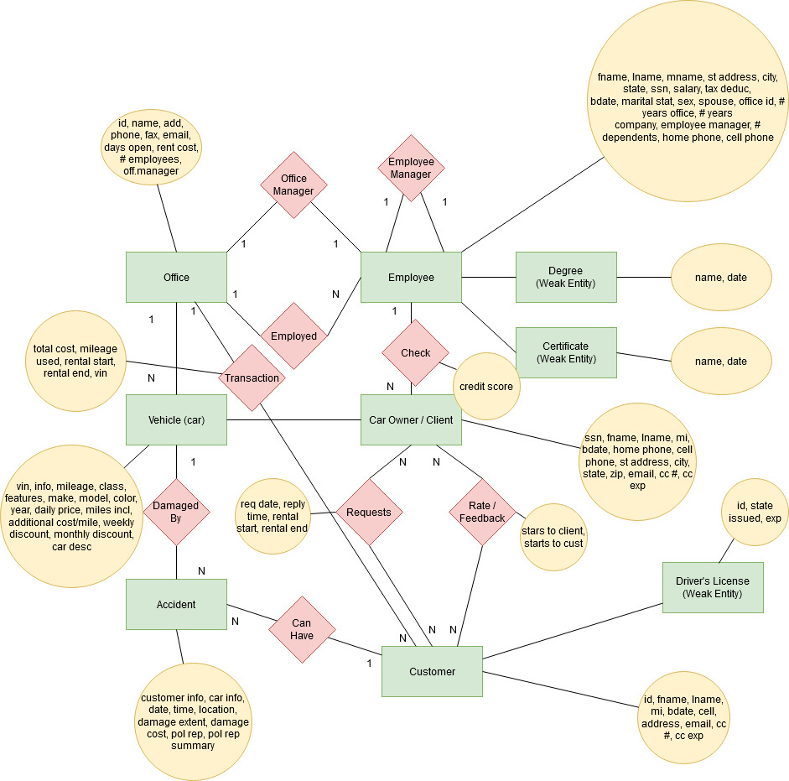

1. Convert your ERM to a Relational Database Schema. Identify the primary and foreign keys. (20 points)

ONLINE OFFICE

(Office ID, Name, Address, Phone Number, Fax Number, Email, Open Date, Rent, # Employees, Office Manager)

(Office ID (PK), Name, Address, Phone Number, Fax Number, Email, Open Days, Rent, # Employees, Office Manager Name)

(Office ID (PK), Name, Street Address, City, State, Zip, Phone Number, Fax Number, Email, Open Days, Rent, # Employees, Office Manager ID (FK))

EMPLOYEE

(FName, LName, MName, Street Address, City, State, SSN, Salary, Tax Deduction, BDate, Marital Stat & Sex, SpouseName, Office, Years Worked at Office, Years Worked at Company, Last Degree & Date, Certs & Dates List, Employee Manager, # Dependents, Home Phone & Cell)

(SSN (PK), Office Name (FK), FName, LName, MName, Street Address, City, State, Salary, Tax Deduction, BDate, Marital Stat, Sex, SpouseName, Which Office, Years Worked at Office, Years Worked at Company, Degree, Cert, Employee Manager, # Dependents, Home Phone, Cell)

(Employee ID (PK), Office Name (FK), FName, LName, MName, Street Address, City, State, Zip, SSN, Salary, Tax Deduction, BDate, Marital Stat, Sex, SpouseName, Which Office (this will be office ID), Years Worked at Office, Years Worked at Company, Degree, Cert, Employee Manager, # Dependents, Home Phone, Cell)

(Employee ID (PK), Office ID (FK), FName, LName, MName, Street Address, City, State, Zip, SSN, Salary, Tax Deduction, BDate, Marital Stat, Sex, Spouse FName, Spouse LName, Years Worked at Office, Years Worked at Company, Employee Manager, # Dependents, Home Phone, Cell)

DEGREE

Degree Name(PK), Employee ID(FK), Date

CERTIFICATION

Degree Name(PK), EMPLOYEE ID(FK), Date

OFFICE MANAGER

(Manager ID (PK), Employee ID(FK))

EMPLOYEE MANAGER

(Manager ID (PK), Employee ID(FK))

CAR OWNER/CLIENT

(SSN, FName, LName, MI, BDate, Home Phone, Cell Phone, Street Address, City, State, Zip, Email, CC # & Exp, Credit Score)

(ID (PK), Office ID (FK), SSN, FName, LName, MI, BDate, Home Phone, Cell Phone, Street Address, City, State, Zip, Email)

CUSTOMER

(ID, FName, LName, MI, BDate, Cell, Address, Email, License State, License #, CC # & Exp)

(ID (PK), License ID (FK), Office ID (FK), FName, LName, MI, BDate, Cell, Street Address, City, State, Zip, Email)

DRIVER’S LICENSE

License #(PK), Customer ID(FK), Issued State, Exp

CREDIT CARD

(Number (PK), Exp, Person ID(FK))

VEHICLE (car)

(Car ID (VIN), Car Info, Current Mileage, Class, Features, Make, Model, Color, Year, Daily Price, Miles Inc, Additional Cost/Mile, Weekly Discount, Monthly Discount, Car Desc)

(Car ID (VIN)(PK), Car Owner / Client ID(FK), Car Info, Current Mileage, Class, Features, Make, Model, Color, Year, Daily Price, Miles Incl, Additional Cost/Mile, Weekly Discount, Monthly Discount, Car Desc)

ACCIDENTS

(Customer Info, Car Info, Date&Time, Location, Damage Extent, Damage Cost, Police Report, Police Report Summary)

(Accident #(PK), Request #(FK), Date, Time, Street Address, City, State, Zip Code, Damage Extent, Damage Cost, Police Report (y/n), Police Report Summary)

REQUEST

(Request ID (PK), Customer ID (FK), Vehicle ID (FK), Location, Reply Date, Reply Time, Client Response(y/n), Rental Date, Drop Off Date)

(Request ID (PK), Customer ID (FK), Vehicle ID (FK), St Address, City, State, Zip, Reply Date, Reply Time, Client Response (y/n), Rental Start Date, Rental End Date)

TRANSACTION

(Transaction #(PK), Request #(FK), Cost, Date, Time, Mileage Used)

RATING

(Rating ID(PK), Request ID(FK), Client Give # Stars, Customer Give # Stars)

CLIENT CHECK

(Client ID(PK), Employee ID(FK), Check Date, Check Time, Credit Score)

CAR LISTED

(Client ID(PK), VIN(FK), Listed Date, Listed Time, Removal Date, Removal Time)

1. List the simple functional dependencies for each table? And list the multiple value functional dependencies for each table? Please list your table first followed by the FD and MVFD for that table (10 points)

ONLINE OFFICE

(Office ID (PK), Name, Street Address, City, State, Zip, Phone Number, Fax Number, Email, Open Days, Rent, # Employees, Office Manager ID (FK))

OFFICE MANAGER

(Manager ID (PK), Employee ID(FK))

EMPLOYEE

(Employee ID (PK), Office ID (FK), FName, LName, MName, Street Address, City, State, Zip, SSN, Salary, Tax Deduction, BDate, Marital Stat, Sex, Spouse FName, Spouse LName, Years Worked at Office, Years Worked at Company, Employee Manager, # Dependents, Home Phone, Cell)

EMPLOYEE MANAGER

(Manager ID (PK), Employee ID(FK))

DEGREE

Degree Name(PK), Employee ID(FK), Date

CERTIFICATION

Degree Name(PK), EMPLOYEE ID(FK), Date

CAR OWNER/CLIENT

(ID (PK), Office ID (FK), SSN, FName, LName, MI, BDate, Home Phone, Cell Phone, Street Address, City, State, Zip, Email)

CLIENT CHECK

(Client ID(PK), Employee ID(FK), Check Date, Check Time, Credit Score)

CAR LISTED

(Client ID(PK), VIN(FK), Listed Date, Listed Time, Removal Date, Removal Time)

CREDIT CARD

(Number (PK), Exp, Person ID(FK))

VEHICLE (car)

(Car ID (VIN)(PK), Car Owner / Client ID(FK), Car Info, Current Mileage, Class, Features, Make, Model, Color, Year, Daily Price, Miles Incl, Additional Cost/Mile, Weekly Discount, Monthly Discount, Car Desc)

CUSTOMER

(ID (PK), License ID (FK), Office ID (FK), FName, LName, MI, BDate, Cell, Street Address, City, State, Zip, Email)

CREDIT CARD

(Number (PK), Exp, Person ID(FK))

REQUEST

Request ID (PK), Customer ID (FK), Vehicle ID (FK), St Address, City, State, Zip, Reply Date, Reply Time, Client Response (y/n), Rental Start Date, Rental End Date)

TRANSACTION

(Transaction #(PK), Request #(FK), Cost, Date, Time, Mileage Used)

RATING

(Rating ID(PK), Request ID(FK), Client Give # Stars, Customer Give # Stars)

ACCIDENTS

(Accident #(PK), Request #(FK), Date, Time, Street Address, City, State, Zip Code, Damage Extent, Damage Cost, Police Report (y/n), Police Report Summary)

1. Normalize your tables. (show your work one table at a time and make sure to state your assumptions in chapter one (if any)) (20 points)

ONLINE OFFICE

0NF

(Office ID, Name, Address, Phone Number, Fax Number, Email, Open Date, Rent, # Employees, Office Manager)

1NF – Address must be St Address, City, State, Zip

(Office ID (PK), Name, St Address, City, State, Zip, Phone Number, Fax Number, Email, Open Days, Rent, # Employees, Office Manager Name)

2NF

(Office ID (PK), Name, St Address, City, State, Zip, Phone Number, Fax Number, Email, Open Days, Rent, # Employees, Office Manager Name)

3NF – Office Manager ID instead of name. This info will be in separate table called Office Manager.

(Office ID (PK), Name, Street Address, City, State, Zip, Phone Number, Fax Number, Email, Open Days, Rent, # Employees, Office Manager ID (FK))

BCNF

(Office ID (PK), Name, Street Address, City, State, Zip, Phone Number, Fax Number, Email, Open Days, Rent, # Employees, Office Manager ID (FK))

4NF

(Office ID (PK), Name, Street Address, City, State, Zip, Phone Number, Fax Number, Email, Open Days, Rent, # Employees, Office Manager ID (FK))

EMPLOYEE

0NF

(FName, LName, MName, Street Address, City, State, SSN, Salary, Tax Deduction, BDate, Marital Stat & Sex, SpouseName, Office, Years Worked at Office, Years Worked at Company, Last Degree & Date, Certs & Dates List, Employee Manager, # Dependents, Home Phone & Cell)

1NF - Split Marital Stat and Sex, Degree and Date, Certs and Date, and Home Phone and Cell / Separate SpouseName into Spouse FName, Spouse LName.

(FName, LName, MName, Street Address, City, State, SSN, Salary, Tax Deduction, BDate, Marital Stat, Sex, Spouse FName, Spouse LName, Office, Years Worked at Office, Years Worked at Company, Last Degree, Date, Certs, Cert Dates List, Employee Manager, # Dependents, Home Phone, Cell)

2NF - Degree and Certs can have their own tables

(FName, LName, MName, Street Address, City, State, SSN, Salary, Tax Deduction, BDate, Marital Stat, Sex, Spouse FName, Spouse LName, Office, Years Worked at Office, Years Worked at Company, Employee Manager, # Dependents, Home Phone, Cell)

3NF - Employee Manager name can be represented by an ID, and this info can be referenced to an Employee Manager table. Office can be represented by an ID and referred to its own table.

(Employee ID (PK), Office ID (FK), FName, LName, MName, Street Address, City, State, Zip, SSN, Salary, Tax Deduction, BDate, Marital Stat, Sex, Spouse FName, Spouse LName, Years Worked at Office, Years Worked at Company, Employee Manager #, # Dependents, Home Phone, Cell)

BCNF

(Employee ID (PK), Office ID (FK), FName, LName, MName, Street Address, City, State, Zip, SSN, Salary, Tax Deduction, BDate, Marital Stat, Sex, Spouse FName, Spouse LName, Years Worked at Office, Years Worked at Company, Employee Manager #, # Dependents, Home Phone, Cell)

4NF

(Employee ID (PK), Office ID (FK), FName, LName, MName, Street Address, City, State, Zip, SSN, Salary, Tax Deduction, BDate, Marital Stat, Sex, Spouse FName, Spouse LName, Years Worked at Office, Years Worked at Company, Employee Manager #, # Dependents, Home Phone, Cell)

4NF – Already at 4NF.

DEGREE

Degree Name(PK), Employee ID(FK), Date

4NF – Already at 4NF.

CERTIFICATION

Degree Name(PK), EMPLOYEE ID(FK), Date

4NF – Already at 4NF.

OFFICE MANAGER

(Manager ID (PK), Employee ID(FK))

4NF – Already at 4NF.

EMPLOYEE MANAGER

(Manager ID (PK), Employee ID(FK))

CAR OWNER/CLIENT

0NF

(SSN, FName, LName, MI, BDate, Home Phone, Cell Phone, Street Address, City, State, Zip, Email, CC # & Exp, Credit Score)

1NF – Split CC# and exp date.

(SSN, FName, LName, MI, BDate, Home Phone, Cell Phone, Street Address, City, State, Zip, Email, CC #, Exp, Credit Score)

2NF – Remove CC# and exp date to its own table.

(SSN, FName, LName, MI, BDate, Home Phone, Cell Phone, Street Address, City, State, Zip, Email, Credit Score)

3NF

(ID (PK), Office ID (FK), SSN, FName, LName, MI, BDate, Home Phone, Cell Phone, Street Address, City, State, Zip, Email, Credit Score)

BCNF

(ID (PK), Office ID (FK), SSN, FName, LName, MI, BDate, Home Phone, Cell Phone, Street Address, City, State, Zip, Email, Credit Score)

4NF – Credit Score goes into ClientCheck table.

(ID (PK), Office ID (FK), SSN, FName, LName, MI, BDate, Home Phone, Cell Phone, Street Address, City, State, Zip, Email)

CUSTOMER

0NF

(ID, FName, LName, MI, BDate, Cell, Address, Email, License State, License #, CC # & Exp)

1NF – Split CC# and exp.

(ID, FName, LName, MI, BDate, Cell, Address, Email, License State, License #, CC #, Exp)

2NF – License # and license state can get their own table. Same goes for CC # and exp.

(ID (PK), License ID (FK), Office ID (FK), FName, LName, MI, BDate, Cell, Street Address, City, State, Zip, Email)

3NF

(ID (PK), License ID (FK), Office ID (FK), FName, LName, MI, BDate, Cell, Street Address, City, State, Zip, Email)

BCNF

(ID (PK), License ID (FK), Office ID (FK), FName, LName, MI, BDate, Cell, Street Address, City, State, Zip, Email)

4NF

(ID (PK), License ID (FK), Office ID (FK), FName, LName, MI, BDate, Cell, Street Address, City, State, Zip, Email)

4NF – Already in 4NF

DRIVER’S LICENSE

License #(PK), Customer ID(FK), Issued State, Exp

4NF – Already in 4NF

CREDIT CARD

(Number (PK), Exp, Person ID(FK))

VEHICLE (car)

0NF

(Car ID (VIN), Car Info, Current Mileage, Class, Features, Make, Model, Color, Year, Daily Price, Miles Inc, Additional Cost/Mile, Weekly Discount, Monthly Discount, Car Desc)

1NF

(Car ID (VIN), Car Info, Current Mileage, Class, Features, Make, Model, Color, Year, Daily Price, Miles Inc, Additional Cost/Mile, Weekly Discount, Monthly Discount, Car Desc)

2NF

(Car ID (VIN), Car Info, Current Mileage, Class, Features, Make, Model, Color, Year, Daily Price, Miles Inc, Additional Cost/Mile, Weekly Discount, Monthly Discount, Car Desc)

3NF

(Car ID (VIN), Car Info, Current Mileage, Class, Features, Make, Model, Color, Year, Daily Price, Miles Inc, Additional Cost/Mile, Weekly Discount, Monthly Discount, Car Desc)

BCNF

(Car ID (VIN), Car Info, Current Mileage, Class, Features, Make, Model, Color, Year, Daily Price, Miles Inc, Additional Cost/Mile, Weekly Discount, Monthly Discount, Car Desc)

4NF

(Car ID (VIN)(PK), Car Owner / Client ID(FK), Car Info, Current Mileage, Class, Features, Make, Model, Color, Year, Daily Price, Miles Incl, Additional Cost/Mile, Weekly Discount, Monthly Discount, Car Desc)

ACCIDENTS

0NF

(Customer Info, Car Info, Date&Time, Location, Damage Extent, Damage Cost, Police Report, Police Report Summary)

1NF – Split Date and time.

(Customer Info, Car Info, Date, Time, Location, Damage Extent, Damage Cost, Police Report, Police Report Summary)

2NF

(Customer Info, Car Info, Date, Time, Location, Damage Extent, Damage Cost, Police Report, Police Report Summary)

3NF

(Customer Info, Car Info, Date, Time, Location, Damage Extent, Damage Cost, Police Report, Police Report Summary)

BCNF

(Customer Info, Car Info, Date, Time, Location, Damage Extent, Damage Cost, Police Report, Police Report Summary)

4NF

(Accident #(PK), Request #(FK), Date, Time, Street Address, City, State, Zip Code, Damage Extent, Damage Cost, Police Report (y/n), Police Report Summary)

REQUEST

4NF – Already in 4NF

Request ID (PK), Customer ID (FK), Vehicle ID (FK), St Address, City, State, Zip, Reply Date, Reply Time, Client Response (y/n), Rental Start Date, Rental End Date)

TRANSACTION

4NF – Already in 4NF

(Transaction #(PK), Request #(FK), Cost, Date, Time, Mileage Used)

RATING

4NF – Already in 4NF

(Rating ID(PK), Request ID(FK), Client Give # Stars, Customer Give # Stars)

CLIENT CHECK

4NF – Already in 4NF

(Client ID(PK), Employee ID(FK), Check Date, Check Time, Credit Score)

CAR LISTED

4NF – Already in 4NF

(Client ID(PK), VIN(FK), Listed Date, Listed Time, Removal Date, Removal Time)

1. Create your Oracle Tables with a complete set of constraints. (20 points)

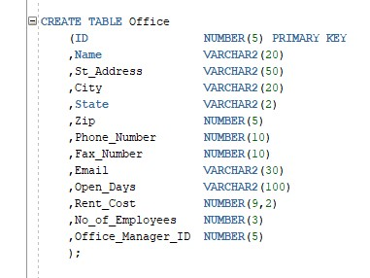

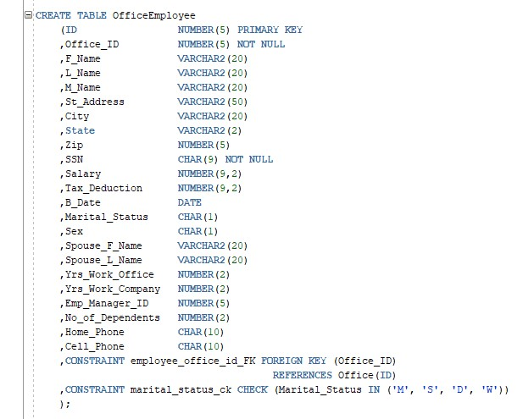

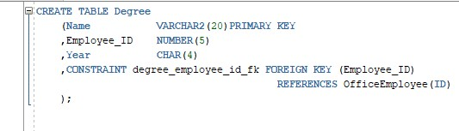

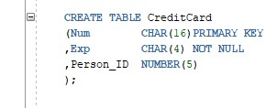

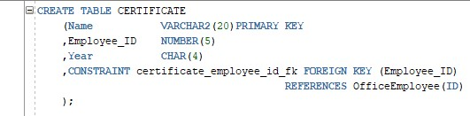

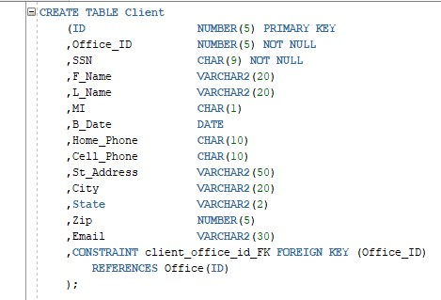

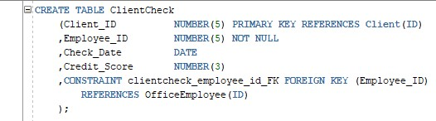

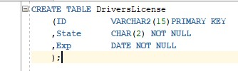

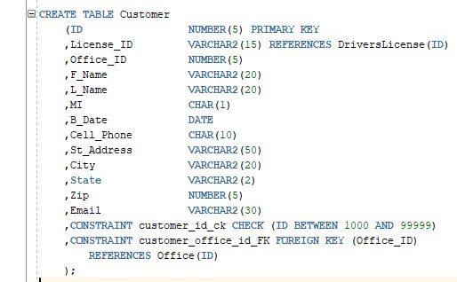

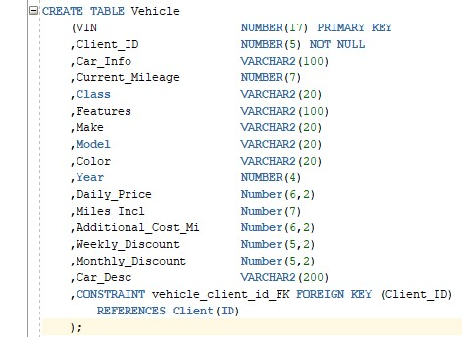

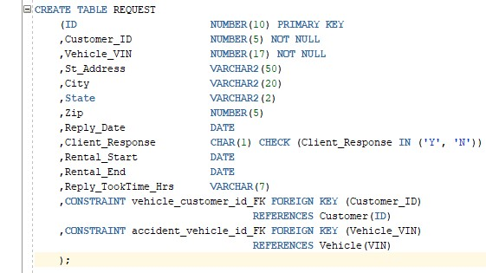

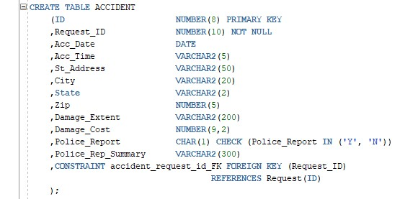

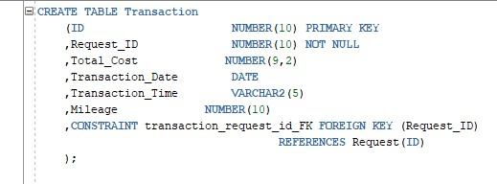

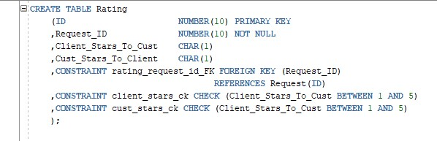

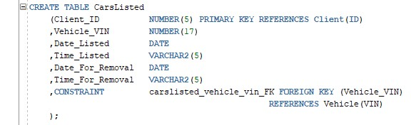

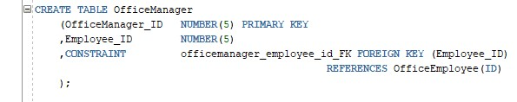

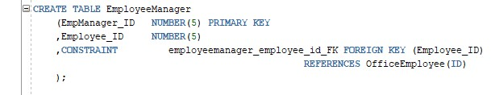

1. Insert **matching** test data records into your tables with at least:
   1. 3 employees
   2. 2 offices
   3. 10 cars
   4. 18 customers
   5. 5 clients
   6. 2 accidents

You do not need to show your insert query.

1. Write a query to list the name of your tables. (5 points)

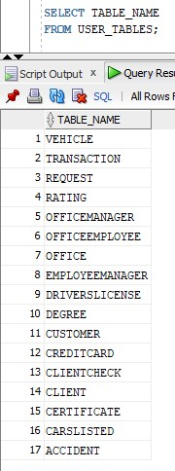

1. Write a query to list the table constraints (table by table). (5 points)

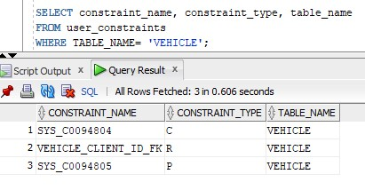

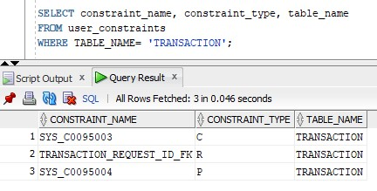

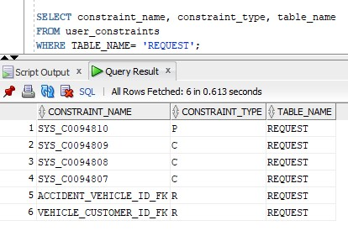

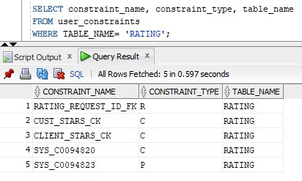

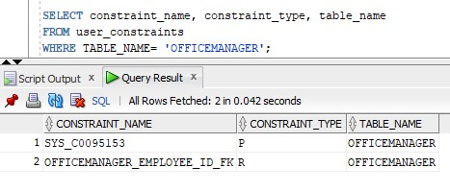

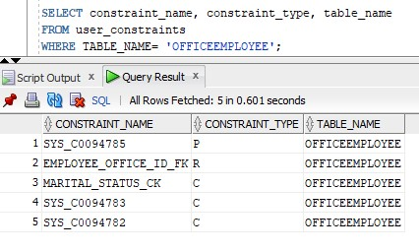

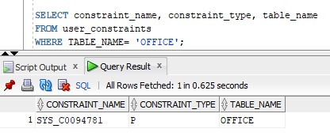

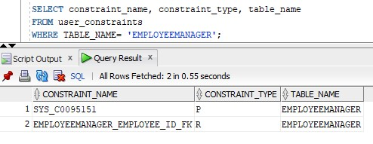

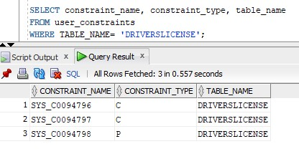

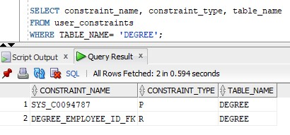

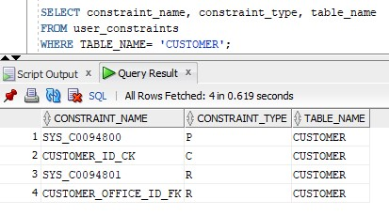

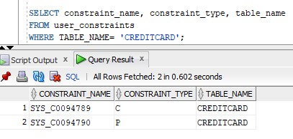

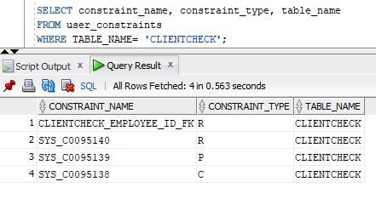

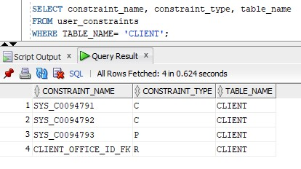

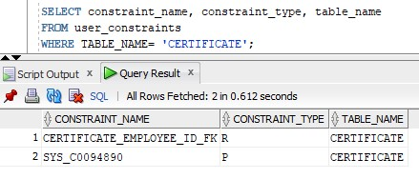

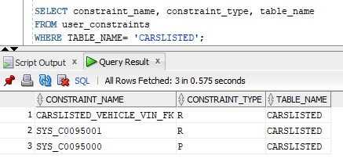

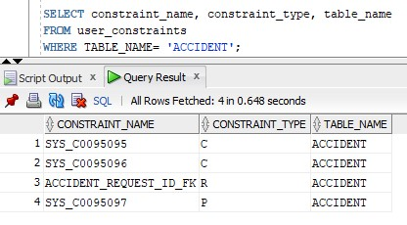

1. Write a query to show the values (data) on each table. (10 points)

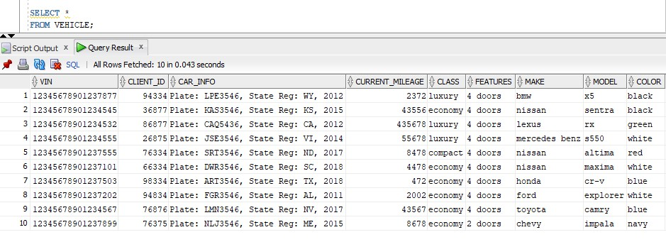

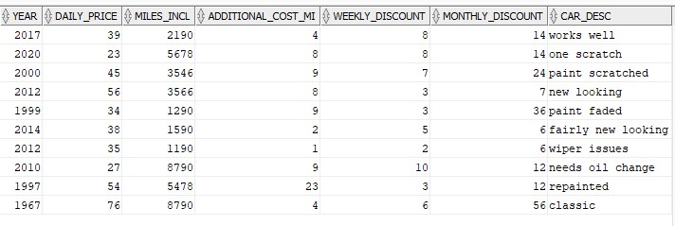

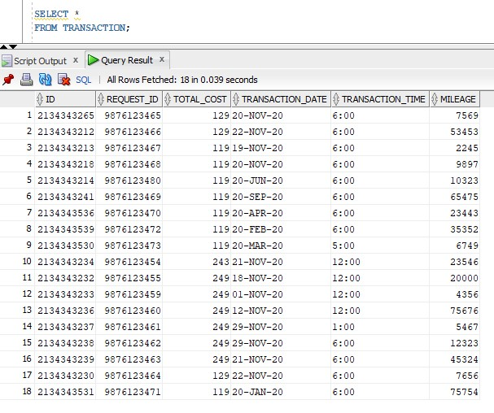

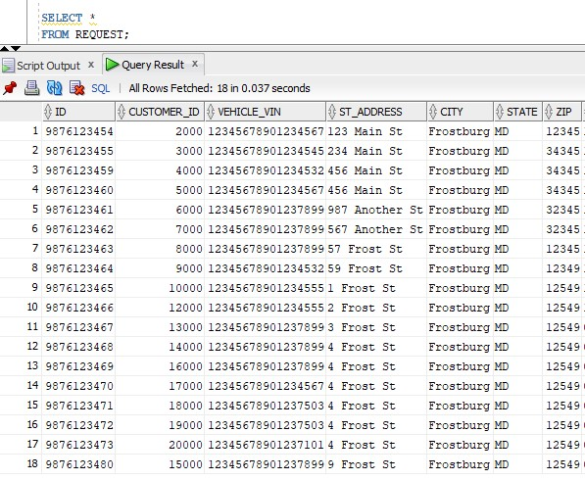

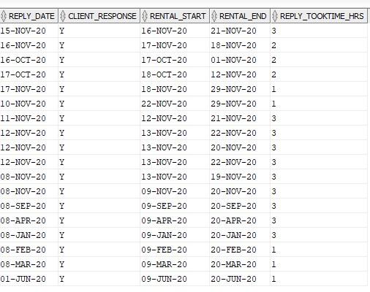

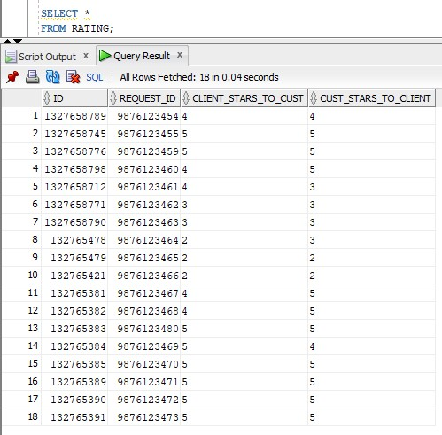

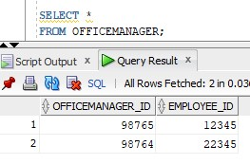

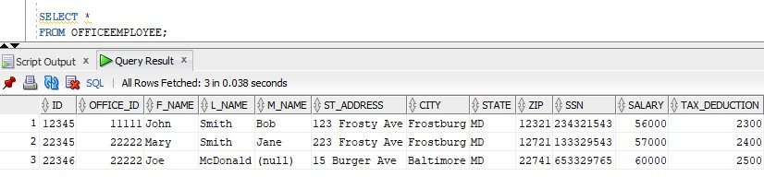



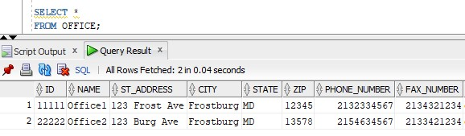

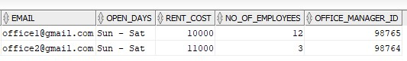

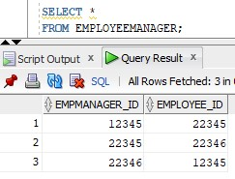

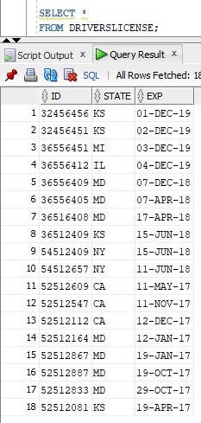

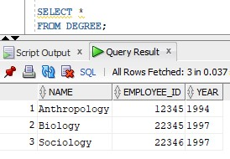

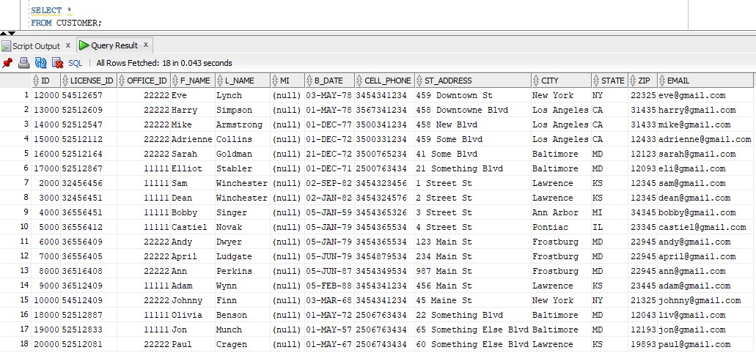

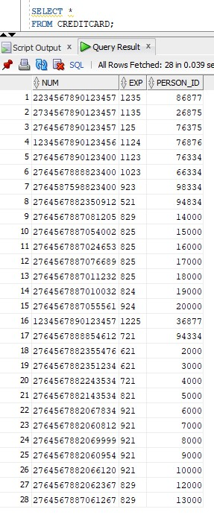

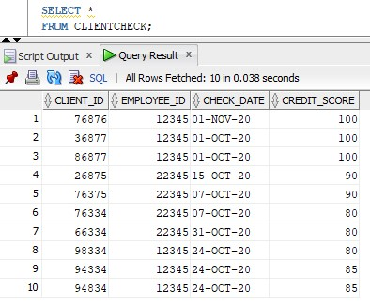

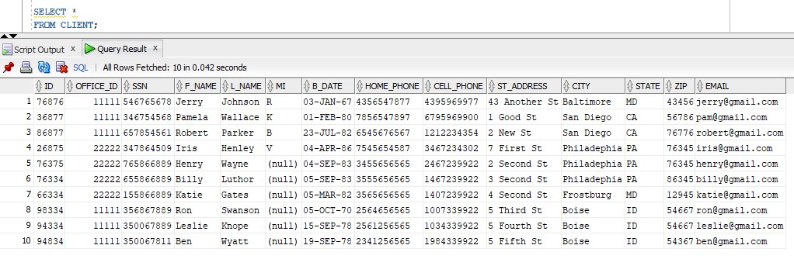

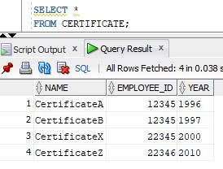

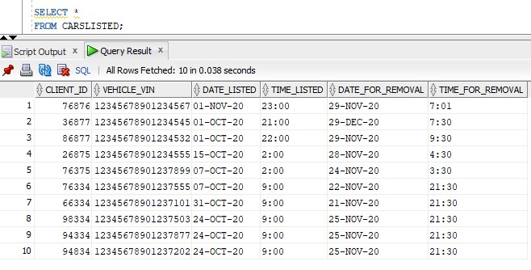

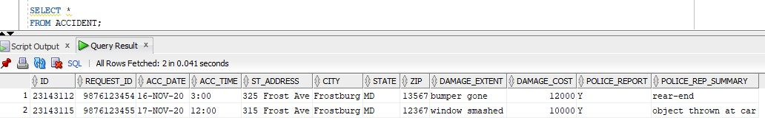

1. Create and run the following queries. Based on your data in your database, your query may/may not return any value. (each 5 points). Please make sure you:
2. State the problem,
3. Query,
4. The results you get after you run the query:
5. Create mailing labels for the employees (name & address).

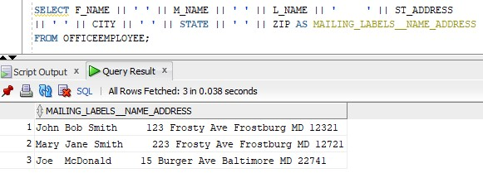

1. Display the name of employees that are office managers.

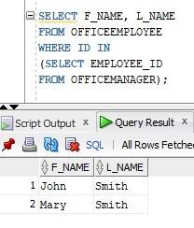

1. Display the first & last name of client with their credit score.

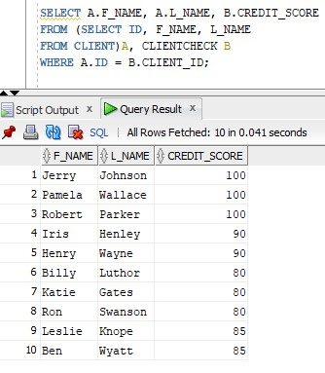

1. Display name of client, name of employee, the date a client was checked, and the office name the employee work at.

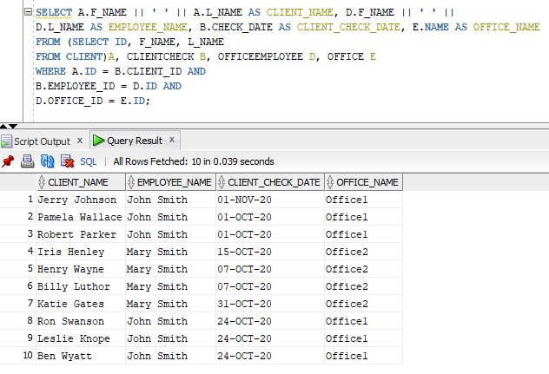

1. Display name of customers who had an accident, car Id, and cost of the damage.

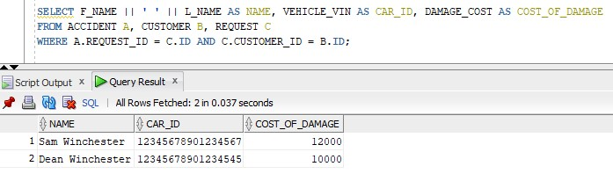

1. Display the total number of cars rented by each customer.

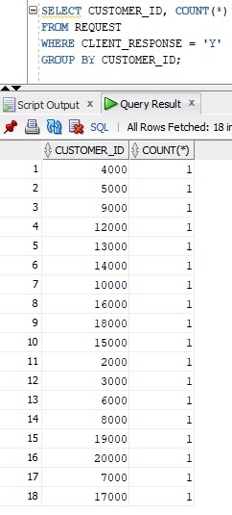

1. Display the number of employees for each office.

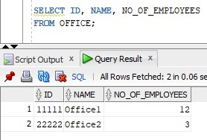

1. Display name, phone number of clients over 30 years old.

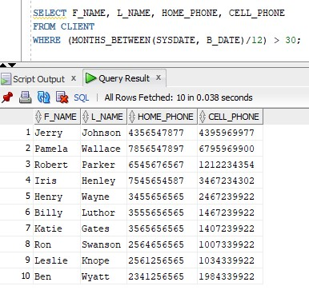

1. Display SSN, address of female employees with more than one certificates.

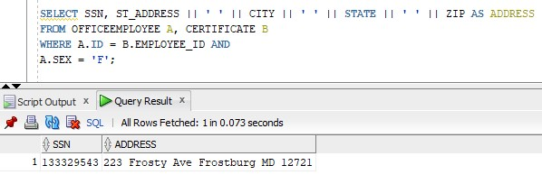

1. Display the total number of cars listed at any given day. User will input the date and time.

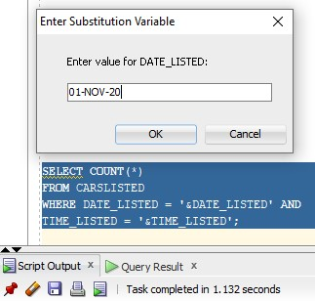

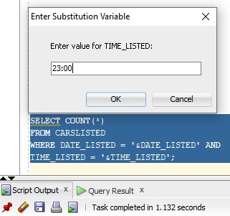

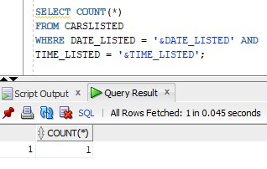

1. List the employees’ name, clients name with score higher than 50 in 2017.

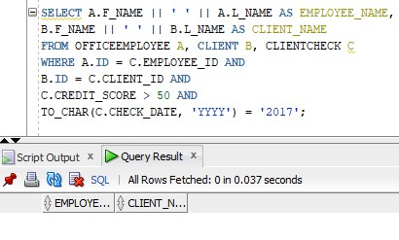

1. List of feedback (client name, customer name, the rating number, who did the rating)

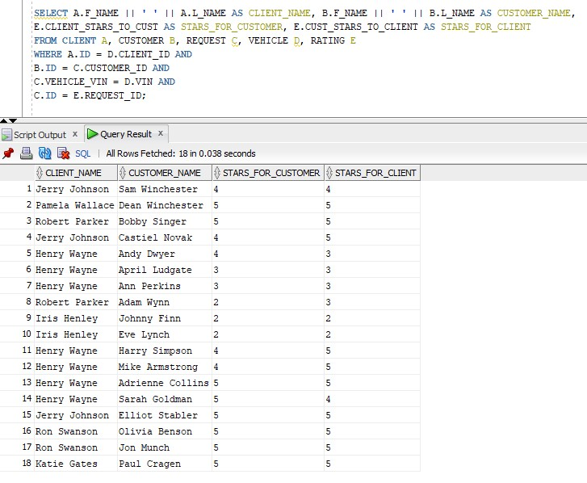

1. The total number of times cars are rented, and the total cost of renting for a given year. User enter the year.

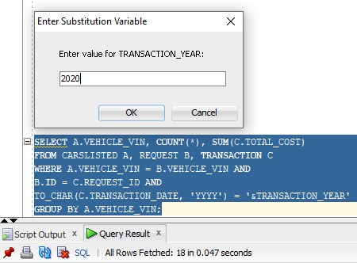

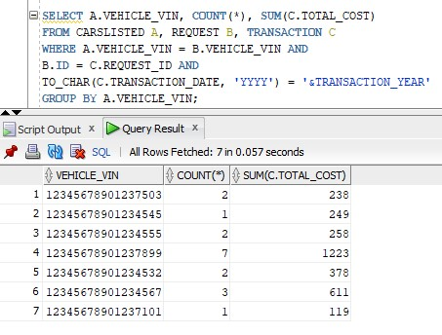

1. List employees’ name who is the manager of an office.

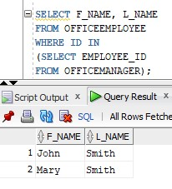

1. Search the database for a client. User input the data. Display client useful info.

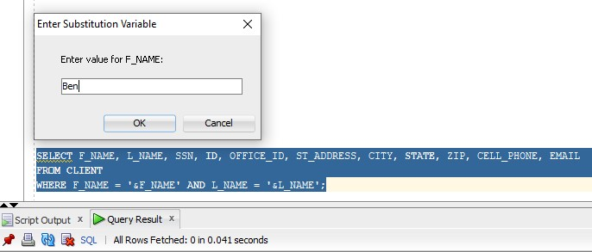

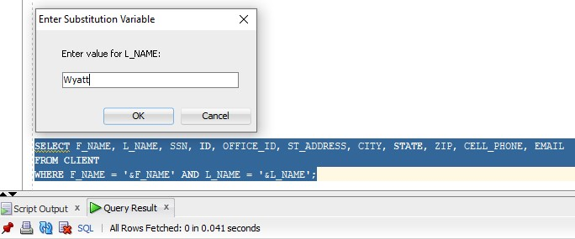

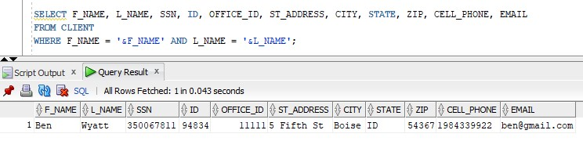

1. Total salary and the number of employee in each office.

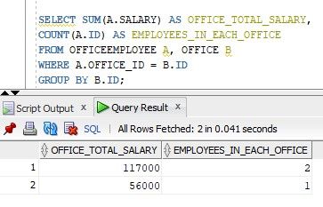

1. List the certificates on an employee. User enter the name.

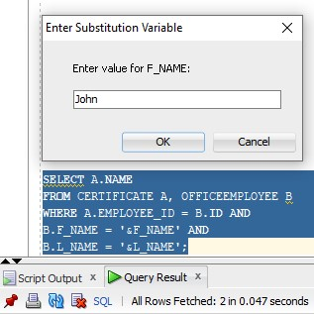

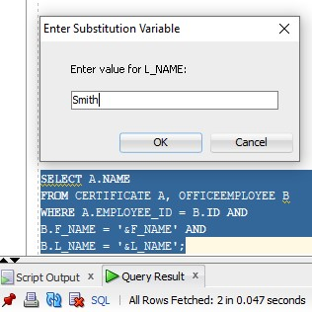

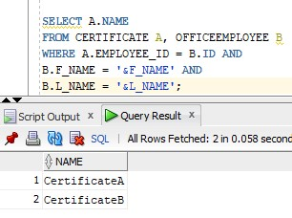

1. List of employees without a cell phone number.

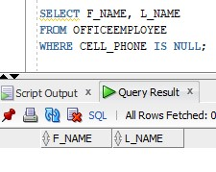

1. Display the total millage used in a given period. User input the start and end date.

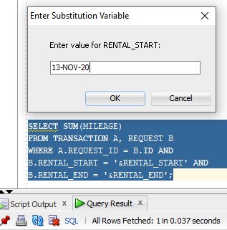

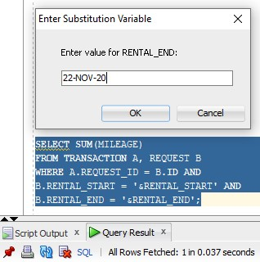

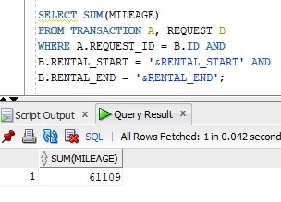

1. Write a useful query that customer my need.

Query: Find all the car IDs that belong to office ID: 11111, and display the weekly and monthly discounts of these cars.

